BROWNIE PAN RECIPE BOOKLET



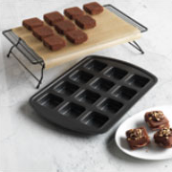

Anna Vierling
Your Pampered Chef Consultant
207-577-0466
http://www.pamperedchef.biz/annaskitchen

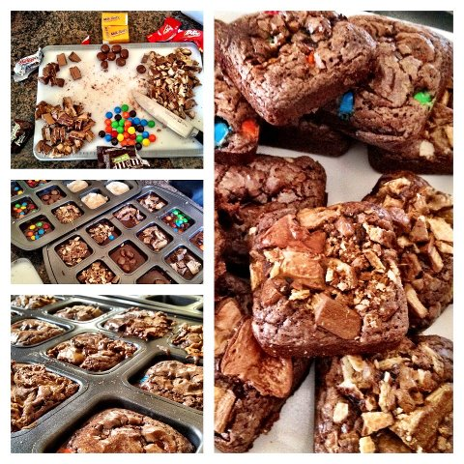

Reese's Cup Cookie Brownies
2 small scoops of chocolate chip cookie dough on bottom – push down with Tart Shaper (or your fingers), then place a small reese cup placed upside down on the cookie dough. Using a Medium Scoop – drop brownie mix on top of Reese's cup. Bake at 350 for about 16-20 minutes. (Until brownie is done) Immediately flip onto Stackable Cooling Rack.

Triple Layer Brownies
2 small scoops of chocolate chip cookie dough on bottom – push down with Tart Shaper (or your fingers), then place one oreo cookie on top of raw cookie dough . Using Medium Scoop drop brownie mix ( 1 box plus ingredients to make cake like) on top of oreo cookie. Bake at 350 for 16-20 mins.

Turtle Fudge Brownies
Fill pan with brownie mix. 3 rolls of Rolos - cut each Rolo in half place 4 rolo 1/2's on top of each brownie square. Sprinkle with chopped pecans. Bake at 325 for 23 mins. Remove from pan and drizzle with melted chocolate.
Chocolate Chip Cookie Sensation
1 ½ tubes of refrigerated chocolate chip cookie dough
2 regular size Snickers bars, chopped
½ cup chopped pecans
½ cup chocolate chips
Caramel ice cream topping (optional)
Ice cream (optional)
Place small scoops of chocolate chip cookie dough on bottom – push down with Tart Shaper (or your fingers). Chop 2 regular size Snickers candy bars and place on cookie dough. Sprinkle with chopped pecans and chocolate chips. Bake 350 for 20-22 mins. Top with ice cream and caramel ice cream topping if desired.

Southwest Cornbread
2 boxes Jiffy Cornbread
2 eggs
1 can creamed corn
3/4 c sour cream
1 1/2 tbsp Southwest Seasoning
1 small poblano pepper chopped fine

Mix it all up and use large Stainless Steel Scoop to put heaping scoops into Brownie Pan cups. Bake at 375 for 20-25 minutes. Top with grated cheese as soon as they come out. These freeze great!!!

Individual Meatloaf (makes two Brownie Pans full)
3 tablespoons olive oil
2 garlic cloves, minced
1 cup finely diced white onion
¼ cup finely diced green bell pepper (OPTIONAL)
1 tablespoon dried basil
1 tablespoon dried thyme
1 tablespoon dried oregano
2 large eggs
1 cup plain whole oats
1 lb. ground beef
1 lb. ground turkey
½ tablespoon salt
½ tablespoon freshly ground black pepper
¼ cup Worcestershire sauce
½ cup canned diced tomatoes, drained
½ cup ketchup mixed with a little brown sugar or just canned diced tomatoes, for topping
Preheat oven to 325*. In a large saute’ pan on medium heat, warm the olive oil, then add the garlic, onion, bell pepper, basil, thyme, and oregano. Saute the vegetables for 3 to 4 minutes, until they begin to soften. In a bowl, whisk together the eggs and milk. Add the oats. In a large bowl, combine the meats well by hand. Season with the salt and pepper. Pour the liquid mixture over the blended meats and mix thoroughly to combine. Add the Worcestershire sauce, tomatoes and sautéed vegetables. Mix well. Place the mixture in brownie pan. Spread the ketchup mixed with a little brown sugar or diced tomatoes evenly on top of the loaf. Bake 325* for 20 minutes!
Remove from the oven and allow to cool for 2-3 minutes before serving

Deep Dish Pizza
- 1 pkg Pillsbury Pizza Crust - using Bakers Roller, roll it out on Large Cutting board and cut into 12 squares; place in Brownie Pan wells.
- 1 pkg turkey breakfast sausage patties, cooked on Small Ridged Baker in microwave; broken up with Mix N Chop; place in wells on top of crust.
- 1/2 can black olives; Use Can Opener and Food Chopper; place in wells
- 1/2 jar spaghetti sauce, 1 medium Stainless Scoop on each well
- 12 ounce block part skim mozzarella; grated with Microplane; sprinkle liberally on top
- Bake at 375F for 15-20 minutes. The outside squares were perfect, the four in the center needed a tad more time but those will be our leftovers!
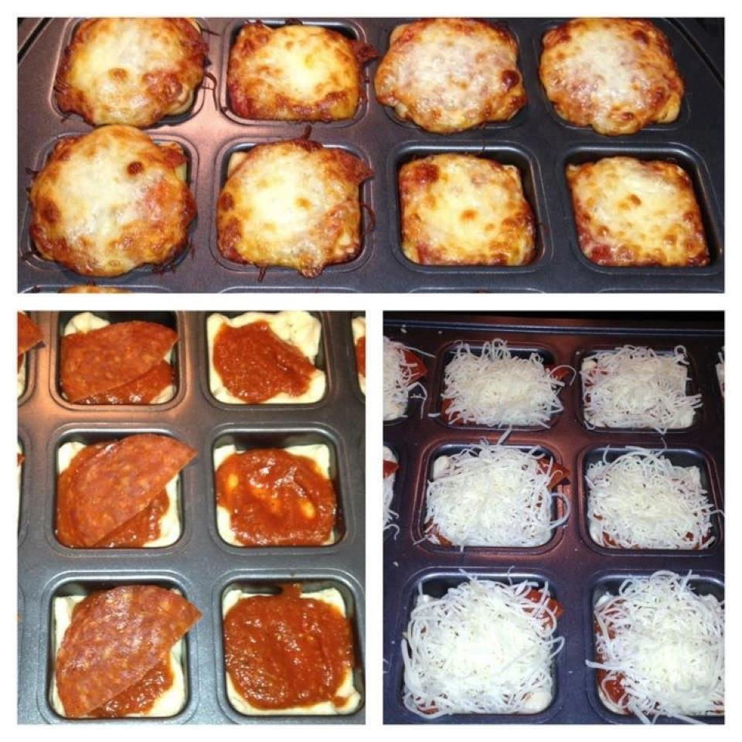

Mini Omelets

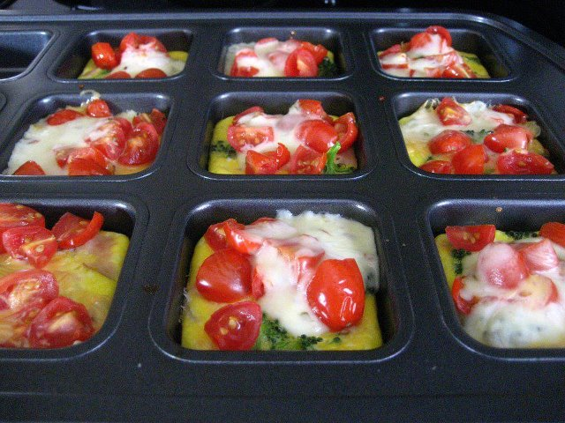

Dozen eggs and some milk whisked in Classic batter bowl... poured into the 12 wells... then add toppings of choice... chopped green pepper and onions, diced ham, mushrooms or tomatoes. Bake 375 for about 17-20 mins... flipped right out and topped with shredded cheese (swiss or cheddar).

12 Perfectly Shaped Mini Lasagnas (makes 2 trays)
1 lb hamburger
1 15oz container ricotta cheese
1 egg
1 box no-boil lasagna noodles
Italian seasoning
2 jars spaghetti sauce
Cheese (I used a combination of Mozzerrella and Cheddar, but whatever you want)

Brown your hamburger. Put a small spoonful of sauce in the bottom of each Brownie Pan well. Shake pan to spread sauce around. Break apart the lasagna noodles. Chances are, you will only get one perfect square out of each noodle, but don't throw away the broken pieces! You can still use them! Just piece them together to make a layer! Place a layer of broken noodles on top of the sauce. Then add a small amount of burger. Mix the egg, ricotta, and Italian seasoning. Place a dollop of mixture on top of burger. Top with another layer of noodle. Press down on the top layer of noodle. You need to have enough space to put another layer of sauce. The no-boil noodles require the moisture of the sauce so you don't want to skimp on it! Fill the well with sauce. Cover with foil and bake at 350 for 25-30 minutes, until the noodles are soft. Top with cheese and bake an additional 5 minutes to melt the cheese.

Double Berry Muffin Squares

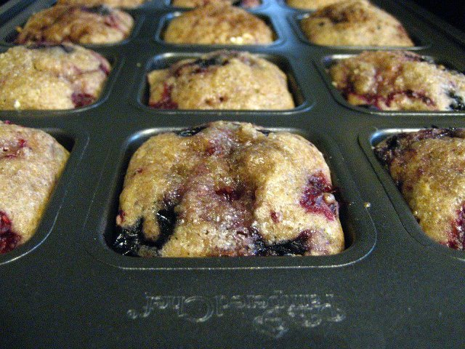

Ingredients:
1/2 cup butter, softened
1 cup sugar
2 eggs, beaten
1/2 cup milk
2 cups flour 1 wheat/ 1 white
2 teaspoons baking powder
1/2 teaspoon salt
1 teaspoon ground cinnamon
1/4 teaspoon ground nutmeg
3 TBSP ground Flax Seed
2 cups fresh blueberries & raspberries, (may use frozen)
Sweet Cinnamon Sprinkle (From Pampered Pantry, get it before it's gone!!)
Preparation:
In a medium mixing bowl, cream together butter and sugar. Add eggs and mix well; stir in milk. Combine dry ingredients and add to the mixture; stir to combine. Gently fold in berries. Fill muffin cups about 2/3 full. Sprinkle tops with a little Sweet Cinnamon Sprinkle. Bake in a preheated 350 degree oven for about 20 minutes, or until lightly browned. (cooking time for non-stick darker pan, may need to adjust temp if using another type of pan)
Makes about 12 muffins plus 9 mini muffins -- yum!

Pineapple Upside Down Cake

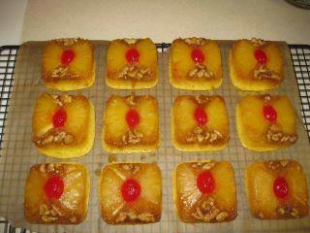

Individual Pineapple Upside-Down Cakes (Based on The Pampered Chef’s recipe in Delightful Desserts, p. 58)
Ingredients: ½ cup of butter
1 cup of packed brown sugar
12 maraschino cherries, halved
One 20-oz. can of pineapple rings with juice
½ cup of walnuts, coarsely chopped
3 eggs
One box of yellow cake mix (18.25 oz. size)
1/3 cup oil
1) Preheat oven to 325 F. Open a can of pineapple rings and drain liquid into 2-Cup Easy Read Measuring Cup using Can Strainer. Add enough water to pineapple liquid to make 1 1/3 cups of liquid. Set aside. Cut pineapple rings into quarters.
2) In Small Batter Bowl, melt butter. Mix in brown sugar. Using Small Stainless Scoop, portion a scant scoop of sugar mixture into each well of two Brownie Pans. Spread to cover bottoms of wells with Skinny Scraper.
3) Add two pieces of the quartered pineapple rings to each well of Brownie Pan. Place one maraschino cherry half in the center of each well. Sprinkle chopped nuts evenly over pineapple slices in pans
4) Combine cake mix, pineapple liquid, eggs, and oil in 4-Qt. Stainless Mixing Bowl. Whisk until well blended. Using Large Stainless Scoop, portion batter into wells of Brownie Pan, filling each well 2/3rds full.
5) Bake cakes for 20-22 minutes until toothpick inserted in center of cakes comes out clean. Cool in pan for 3 minutes, then invert onto parchment-lined Stackable Cooling Rack. Serve warm with whipped topping, if desired. Makes 24 individual cakes. NOTE: Recipe may be halved to fill just one Brownie Pan and make 12 servings. Use a small cake mix (like Jiffy brand) or 1 2/3 cups of dry cake mix, 2 eggs, and 2/3 cup of pineapple liquid, plus 2 T. oil. Use half the butter, sugar, pineapple and cherries

Mini Corn Dog Nuggets

Make your corn bread like normal, scoop into the wells and drop sliced hot dog into each. Bake and BAM!! Kids have a hand held meal!! Or you could use croissants and wrap them.. If you don’t do hot dogs you could do some CHICKEN!!

Mini Apple Pies

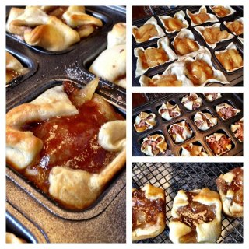

1 package of crescent roll creations
1 can of sugar free apple pie filling
5 Tbs of flour
2 Tbs of sugar
1/2 tsp cinnamon
2 tbs butter
Preheat oven to 350. Roll out dough and use the bakers roller to flatten and enlarge dough. Use the pizza cutter to cut into squares. Place dough in the brownie pan. Use the medium scoop to place into the pan on top of dough.
In a separate bowl mix flour, sugar and cut in butter til crumbly. Add to the top of each square.
Pull corners to the middle and add another dash of the crumble. (You might half the mixture or just go crazy and add a lot depending on how much topping you like)
Bake for 15 -17 minutes or until golden brown.
Remove from pan immediately. Serve with ice cream or eat them COLD :) Either way is AMAZING!

Healthy Dinner Cupcakes
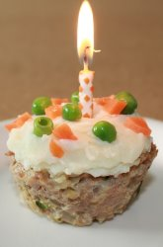
Vegetable oil
½ pound ground turkey
½ cup zucchini, grated
1/3 cup onions, finely chopped
¼ cup breadcrumbs
1 egg white
½ teaspoon salt
¼ teaspoon garlic powder
1 cup mashed potatoes
¼ cup carrots, cooked and finely chopped
¼ cup cooked peas

Preheat oven to 400 degrees.
Combine the turkey, zucchini, onions, breadcrumbs, egg white, salt, and garlic powder together and mix well to form a meatloaf mixture.
Lightly grease the wells of the Brownie Pan with vegetable oil.
Spoon the turkey mixture into the wells of the Brownie Pan so that each tin is filled to the top but not overflowing. Smooth with a spoon so the tops are flat.
Place the turkey cupcakes in the oven and bake until the internal temperature reads 165 degrees, about 20-25 minutes.
Remove the cupcakes from the oven and let cool for a few minutes, and then carefully remove them from the pan. You may want to use a knife or spatula to gently loosen them before removing them.
Arrange the cupcakes on a plate and "frost" them with the mashed potatoes.
Finish the cupcakes by scattering carrot and pea "sprinkles" on top for decoration.
Recipe adapted from education.com

Michele's Mini Irish Soda Breads

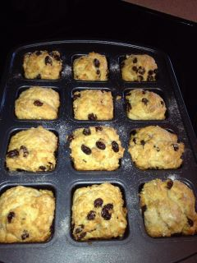

2/3 cup raisins (I like to boil them first so they are nice and soft in the bread)
2 C flour
1 1/2 tsp. baking powder
3/4 tsp baking soda
1 tsp salt
3 tbs. sugar
3 tbs. softened butter
1 Cup buttermilk
additional melted butter and sugar
Blend all ingredients but the additional butter and sugar. Divide evenly among wells of Brownie Pan. Drizzle melted butter and sugar on top. Bake at 325 for about 20 minutes.

Weight Watcher Brownies
1 Box Ghiradelli Double Chocolate Fudge Brownie Mix
15 oz can solid pumpkin

Mix dry brownie mix and solid pumpkin till incorporated. Place one large scoop in each well of Brownie Pan. Bake at 350 for 22 mins.

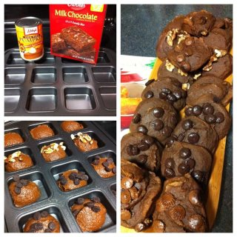

Mix can of solid pumpkin and brownie mix together, bake at 400 for 20 mins.
4 points a brownie without candy toppings! Enjoy :)

Cinnamon Sugar Loaves

¾ cup flour

1-½ teaspoon baking powder

½ teaspoon salt

... ½ teaspoon nutmeg

½ teaspoon cinnamon

⅓ cup oil

¾ cup granulated sugar

1 egg

¾ cup milk

For the Cinnamon Sugar Topping:

1/4 cup butter, melted

1/3 cup granulated sugar

1 Tablespoon cinnamon

Preheat the oven to 350º. Whisk together the flour, baking powder, salt, nutmeg, and cinnamon in Classic Batter Bowl.

In a small batter bowl whisk together oil, sugar, egg and milk.

Add dry ingredients and stir only to combine.

Use the large scoop to divide among brownie pan. Bake at 350 degrees for 15-20 minutes.

Remove from pan immediately. Combine sugar and cinnamon. Dip into butter then dip into cinnamon. Serve and enjoy. Make sure you save yourself one they will go FAST

